Tyler SIS Student 360 Mobile

Overview
Tyler SIS Student 360 Mobile is a mobile phone app version of the Tyler SIS Student 360 Parent Portal available on both iOS and Android. It can be downloaded from the Apple iTunes iOS App Store and the Google Play App Store.
The app is compatible with iPhones and iPads running iOS 7 or later and Android devices running Android 4.4 and later. While Tyler SIS Student 360 Mobile is compatible with larger devices, it contains a subset of the features available in the browser application. You can use the browser app on larger devices with Chrome on Android and Safari on iOS.
The Android and iOS versions are similar, but differences in hardware and platforms will result in slightly different appearances on some screens. Such differences are highlighted in this document.

Installing Tyler SIS Mobile
Download Tyler SIS Student 360 Mobile from Apple iTunes or Google Play. The app is free.
- Android (Phone and tablet)
- iOS (iPhone and iPad)

Logging in
The first time you launch Student 360, you will be prompted to search for your district either by name or by ZIP code. If you select the wrong district or need to change districts, you will be able to do so later from the Settings screen.
Not all Tyler SIS districts are using Student 360. If you downloaded this document from a district where you have no students enrolled, it is possible that you will not be able to find your district.
If for any reason you cannot find your district on the search screen, please wait until you receive an announcement from your district that Tyler SIS Student 360 is available.
Upon tapping Continue, enter at least the first three letters of the district’s name or the first three digits of the district’s ZIP code. Tap the Search button to search for districts. Tap the district where your student is enrolled to proceed to the login page.

Left: iOS, Right: Android
At the top of the login screen, the gear icon provides access to the settings screen. To log in, use the radio buttons (Android) or tabs (iOS) to select Staff, Parent, or Student login. Use the same User Name and Password that you use to log into the Tyler SIS Student 360 Parent Portal website. Use the checkbox (Android) or toggle switch (iOS) to save your User Name if you want, then tap Login.

Navigating Tyler SIS Student 360 Mobile
Left: iOS, Right: Android
Within Tyler SIS Student 360, the Top Bar of the application will have several icons that help you navigate the app.
- - return to the list of students (hidden if logged in as a student, or if only one student is found in the household)
- - refresh the screen
- - log out of Tyler SIS Student 360 Mobile.
Android devices have a built-in Back button, either at the bottom of the screen or as a hardware button on the device. Tyler SIS uses this built-in Back functionality to return to the previous screen. On iOS, since there is no Back button, a standard left-pointing arrow at the top of the screen with a label will take you back to the previous page.

Student List View
Left: iOS, Right: Android
If you are logging in as a parent and your household has more than one student, the first screen will be the Student List view. A student login will only see their own information, regardless of how many other students are in the household.
All of the actively-enrolled students will display with their photos (or a placeholder if their photo isn’t in Tyler SIS) along with their name, grade level, enrolled school, and student number. Tap a row to see that student’s Student Summary screen.

Student Summary
The Student Summary screen shows all of the areas available in Tyler SIS Student 360 for the selected student. Note that some of these items may not appear if they are not enabled by your district.
At the top of the screen, the student’s name, number, primary enrollment school, and grade level are displayed on the left, while the student’s photo appears on the right.
Some tiles may appear yellow to indicate that there is an alert to see. In this case, the Attendance tile is yellow to indicate that the student was absent for all or part of the current day.
To see more detail about an area, tap the tile to be taken to that screen.

Assignments
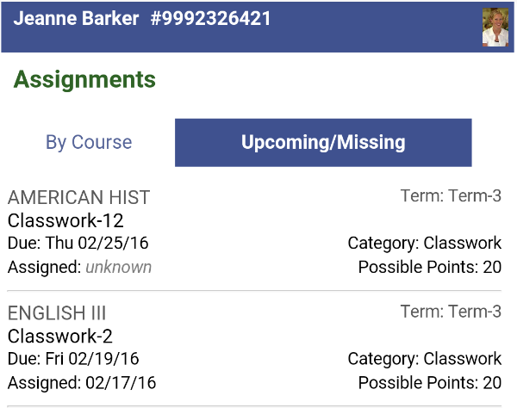
The Assignments screen has two views: Upcoming/Missing and By Course. Some assignments may display a color-coded status:
- Due tomorrow: green
- Due today: orange
- Missing: red
- No score yet recorded (not marked missing): blue
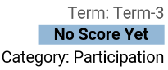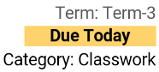
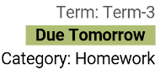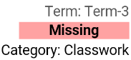

Upcoming/Missing
The Upcoming/Missing view displays by default. This screen shows all assignments due in the past 30 days and those that will be due in the next 30 days in chronological order.

By Course
On the By Course screen, use the drop-down selectors to pick the Course and Term you want to view. All assignments for that course that are due during the term display.

Attendance
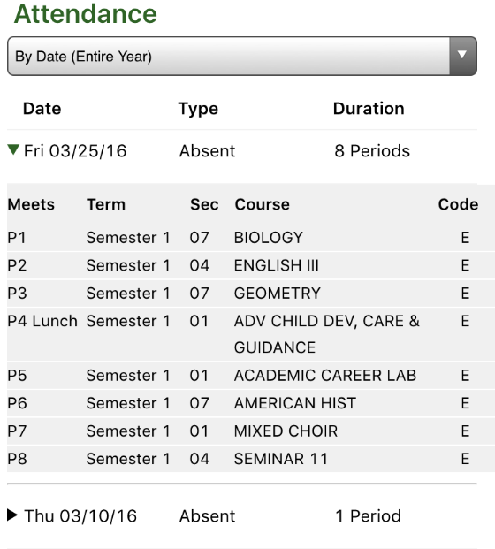
The Attendance screen shows all of the dates where the student was absent for all or part of the day. You can view the absences sorted By Date (Entire Year) or By Course Schedule for a specific term. Use the drop-down at the top to switch between views.
When viewing attendance By Date, each date is listed. Tap a date to see the courses where the student was marked absent. When viewing attendance By Course Schedule, tap a course and all of the dates where the student was marked absent in the course will display. Regardless of the view you choose, the period, term, and absence code will display.

Course Schedule
The Course Schedule screen shows the courses in which the student is enrolled for three time periods. Switch between these views using the tabs at the top of the screen.
- Today – shows only the courses that meet today
- Term – shows only the courses that meet in the current term
- All – shows all courses on the student’s schedule
Each course displays with the room number, term, name, and teacher. If the teacher has an email address, an icon appears and the name will be underlined. Tapping a teacher’s name will start an email to the teacher.

Discipline
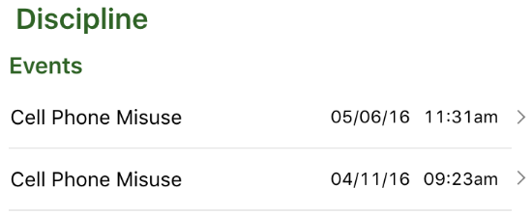
The Discipline screen shows any discipline events where the student was involved. Each event shows the incident, date, and time.
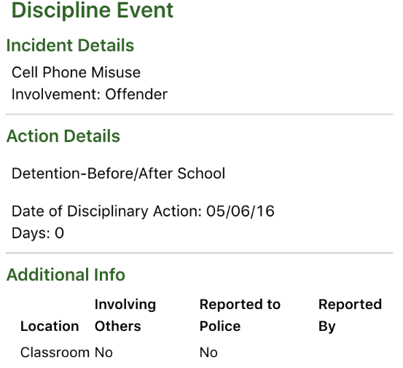
Tapping on a row loads additional information about the event, including any disciplinary actions.

Grades
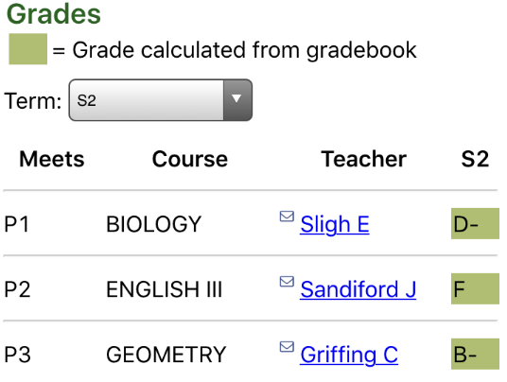
The Grades screen shows all report card grades for the student. Each course displays with its name, the period it meets, the teacher, and the term grade. If the teacher has an email address, an icon appears and the name will be underlined. Tapping a teacher’s name will start an email to the teacher.
Use the Term drop-down to select a term. Grades that are calculated from in-progress gradebook scores display in green, while posted grades for past terms display with no highlight.

Student Details
The Student Details screen shows contact and personal information about the student. This screen shows the student’s enrollment status and birthdate at the top. All The remainder of this screen is split into four sections:
- Current Location – the course and room number where the student is currently (during the school day)
- Contacts – Household Parents – the contacts that live at the student’s mailing address
- Contacts – Additional – the nonresident parents
- Contacts – Emergency – the emergency contact information for the student
Note that Household and Additional contacts will only display if you are a contact of that type.

